# ARIGNAR ANNA GOVERNMENT ARTS COLLEGE-MUSIRI 621 211

# Affiliated to Bharathidasan University, Tiruchirappalli

# TOPIC

# ESTIMATION OF BUSINESS EXPENSES

SUBMITED BY:

TEAM ID: NM2023TMID08543

TEAM LEADER:

1. KIRTHUTHIKA M (411B17E95F6C379AA334DF9B8EA05EF6)

TEAM MEMBERS:

1. NADHIYADEVI T (17A82606329E1BF91134E0B2AD28FB77)
2. VINITHA M (EDC9D68A09319B3A17E441E46BFB3448)
3. HEMALATHA S (FA43FF9A181844791FD40486A0D8726B)

**INTRODUCTION:**

**This report deal’s into the fascinating realm of business expenses and provides a visual of the various expenditures incurred distribution of expenses, identifies key cost drivers, and highlights areas of potential optimize or concern. Exploration Business expenses are costs associated with running a company. When you know all of a company’s expenses, you can create more accurate budget and track spending. Expenses are also a part of a company’s income sheet. You must know a business’s expenses to calculate a final net profit. Costs are subtracted from revenue to determine a company’s taxable income. To extract the insights from the data and put the data in the from visualizations, Dashboards and story we employed Tableau tool.**

**MILESTONE 1: DEFINE PROBLEM/PROBLEM UNDERSTANDING**

**ACTIVITY 1: SPECIFY THE BUSINESS PROBLEM**

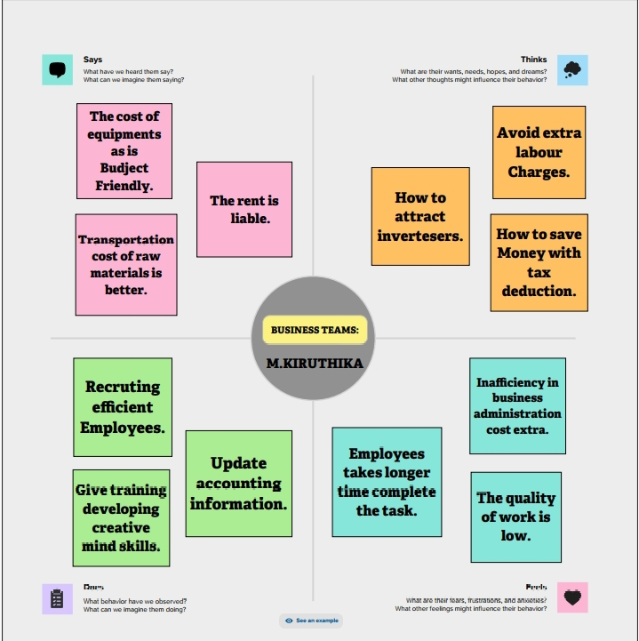

**ACTIVITY 2: BUSINESS REQUIREMENTS**

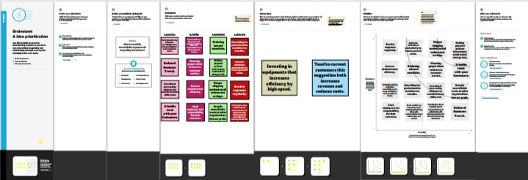

**MILESTONE 2: DATA COLLECTION**

**Data collection is the process of gathering and measuring information on variables of interest, in an established systematic fashion that enables one to answer stated research questions, test hypotheses, evaluate outcomes and generate insights from the data.**

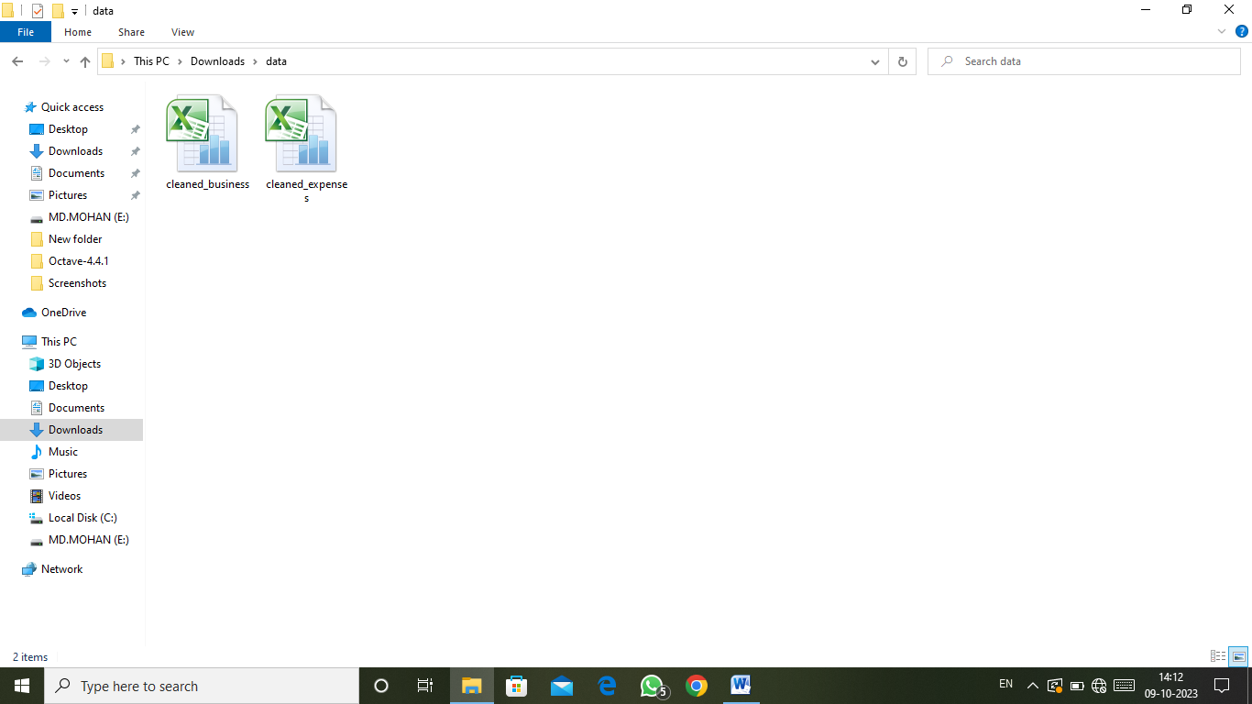

**ACTIVITY 2: CONNECT THE DATASET WITH TABLEAU**

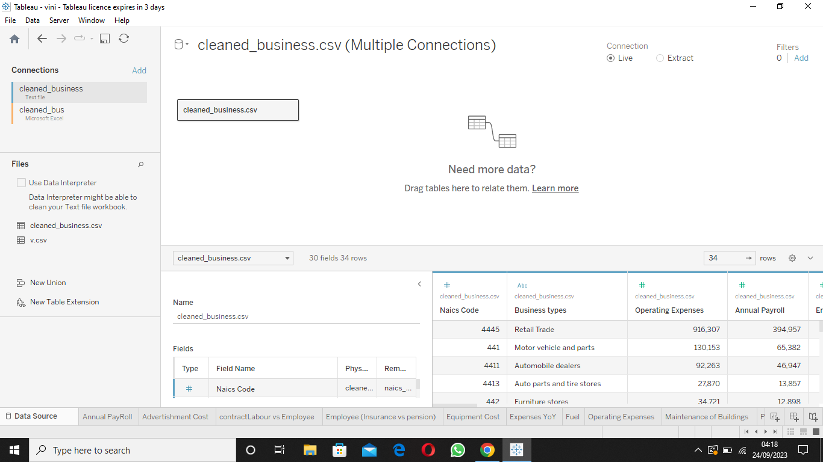

**MILESTONE 3: DATA PREPARATION**

**Preparing the data for visualization involves cleaning the data to remove irrelevant or missing data, transforming the data into a format that can be easily visualized, exploring the data to identify patterns and trends, filtering the data to focus on specific subsets of data, preparing the data for visualization software, and ensuring the data is accurate and complete. This process helps to make the data easily understandable and ready for creating visualizations to gain insights into the performance and efficiency.**

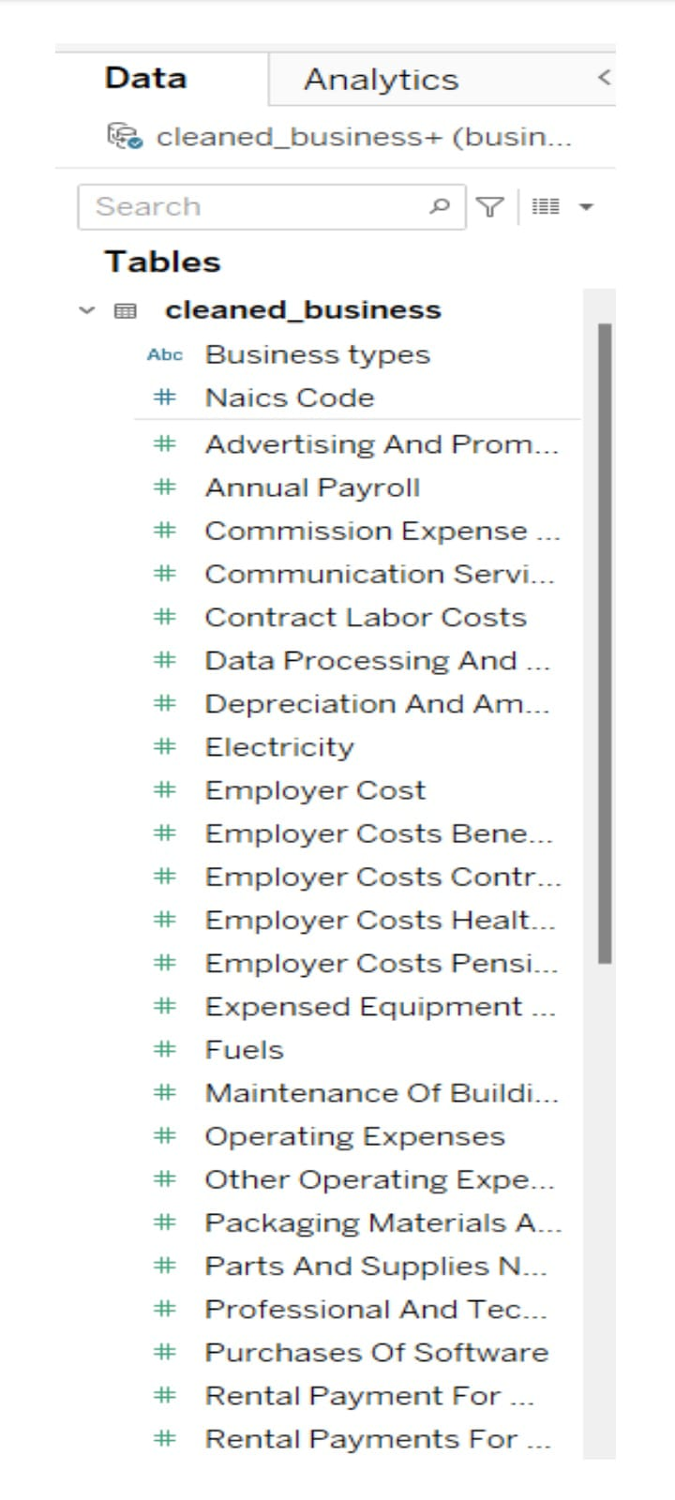

**MILESTONE 4: DATA VISUALATION**

**Data visualization is the process of creating graphical representations of data to help people understand and explore the information. The goal of data visualization is to make complex data sets more accessible, intuitive, and easier to interpret. By using visual elements such as charts, graphs, and maps, data visualizations can help people quickly identify patterns, trends, and outliers in the data.**

**ACTIVITY 1: NO OF UNIQUE VISUALATIONS**

**The number of unique visualizations that can be created with a given dataset. Some common types of visualizations that can be used to analyse the performance and efficiency of banks include bar charts, line charts, heat maps, scatter plots, pie charts, Maps etc.**

**ACTIVITY 1.1: ANNUAL PAYROLL**

[**https://drive.google.com/file/d/1zLk-BsxENcqGDV0AfuaP694WgLzVA4qU/view?usp=drive_link**](https://drive.google.com/file/d/1zLk-BsxENcqGDV0AfuaP694WgLzVA4qU/view?usp=drive_link)

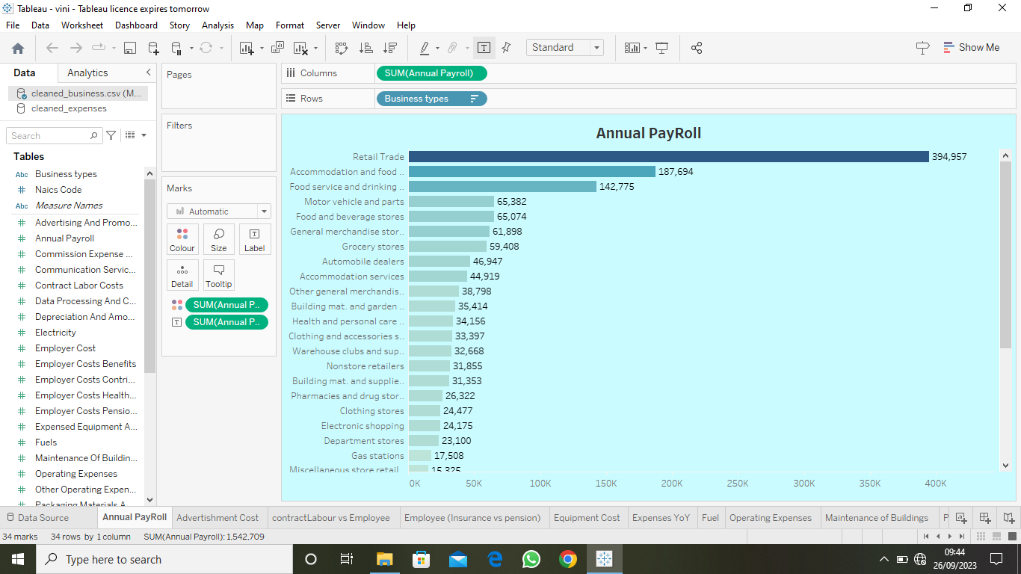

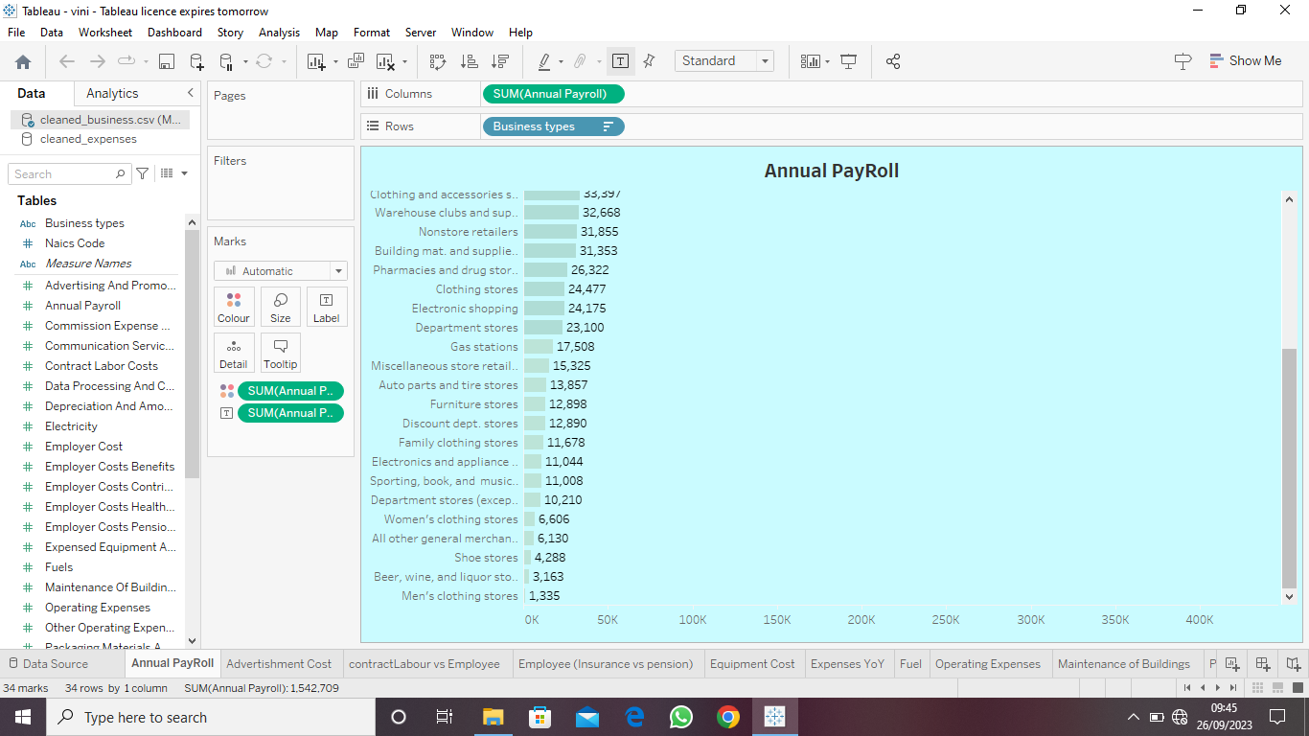

**ACTIVITY 1.2: ADVERTISEMENT COST**

[**https://drive.google.com/file/d/1e3VHra0ZETV9gSPCV5cTT2CP8MLOo88t/view?usp=drive_link**](https://drive.google.com/file/d/1e3VHra0ZETV9gSPCV5cTT2CP8MLOo88t/view?usp=drive_link)

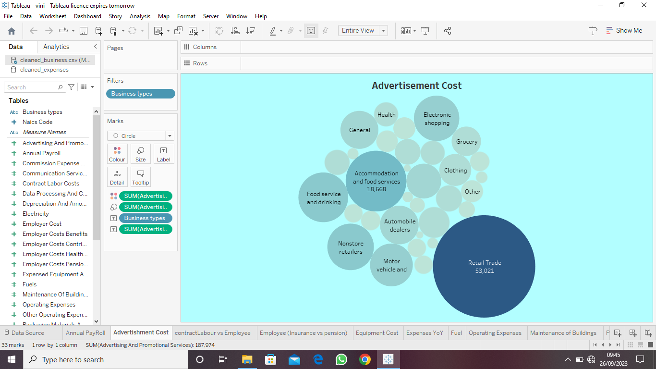

**ACTIVITY 1.3: CONTRACT LABOUR VS EMPLOYEE**

[**https://drive.google.com/file/d/14n283zK1h0_5ryq8a18G0sLcTOEu19NL/view?usp=drive_link**](https://drive.google.com/file/d/14n283zK1h0_5ryq8a18G0sLcTOEu19NL/view?usp=drive_link)

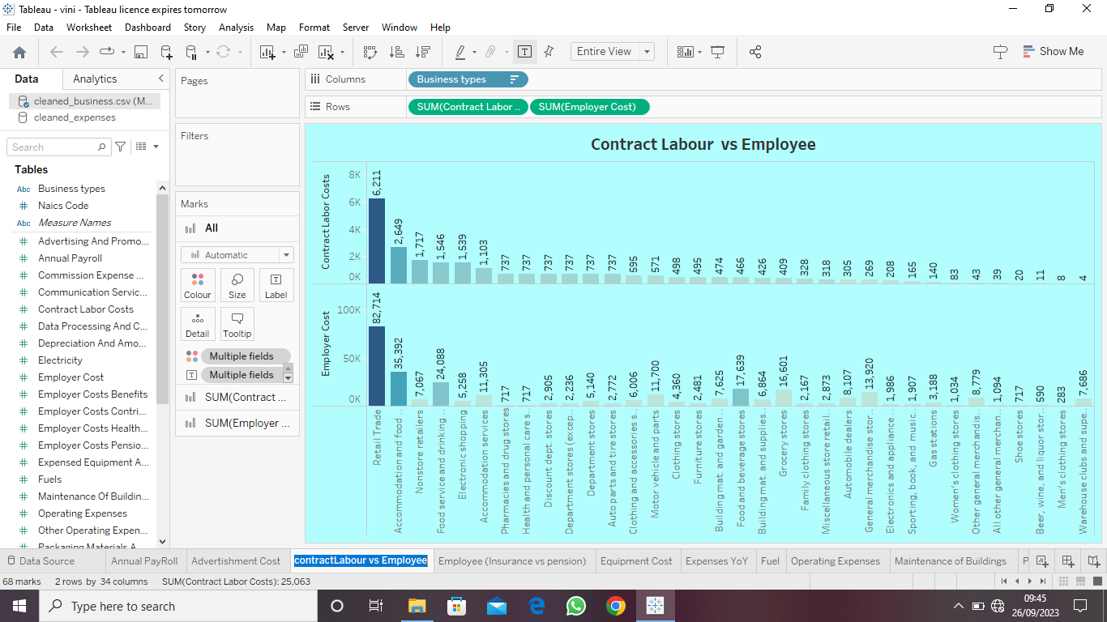

**ACTIVITY 1.4: EMPLOYEE (INSURANCE VS PENSION)**

[**https://drive.google.com/file/d/1edz2zz5O1lgTJkXjPYuZ8SbfyBqk6qat/view?usp=drive_link**](https://drive.google.com/file/d/1edz2zz5O1lgTJkXjPYuZ8SbfyBqk6qat/view?usp=drive_link)

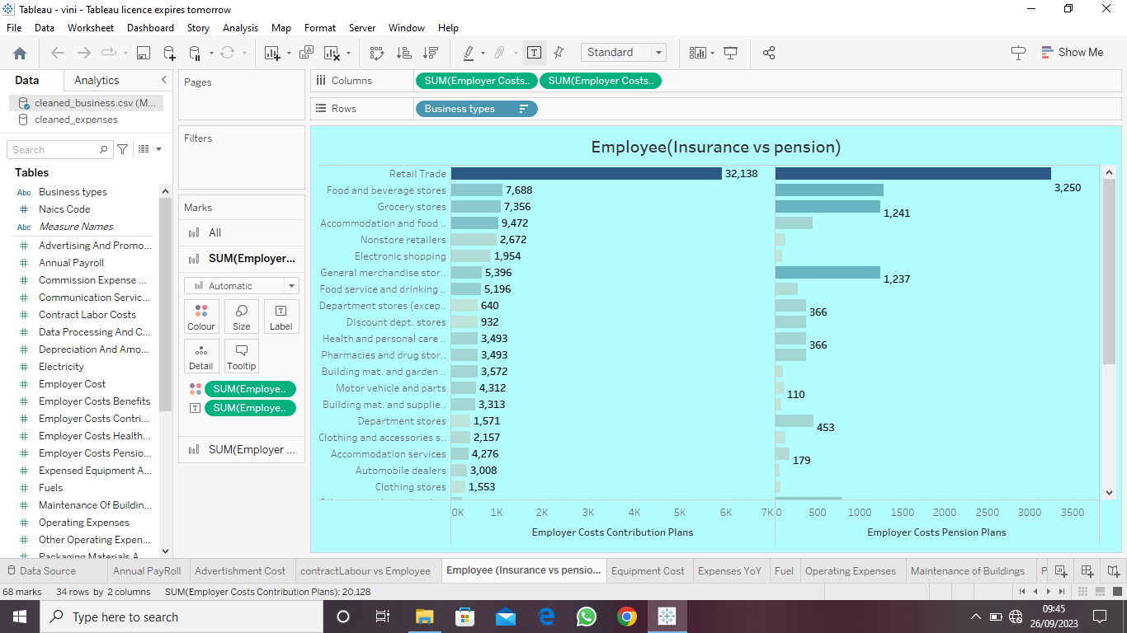

**ACTIVITY 1.5: EQUIPMENT COSTS**

[**https://drive.google.com/file/d/13N1fxFjsDOourmF-kRbxYtjEHklW28-q/view?usp=drive_link**](https://drive.google.com/file/d/13N1fxFjsDOourmF-kRbxYtjEHklW28-q/view?usp=drive_link)

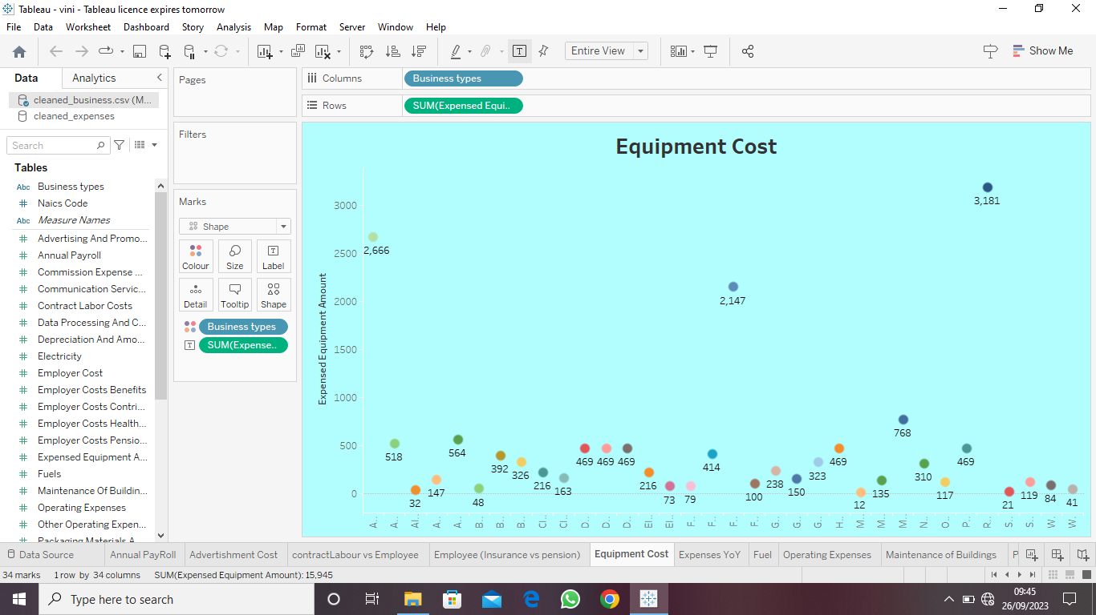

**ACTIVITY 1.6: EXPENSES YOY**

[**https://drive.google.com/file/d/1zexazhhYuEgCGbIBFY_g5xT4tP4ArhHg/view?usp=drive_link**](https://drive.google.com/file/d/1zexazhhYuEgCGbIBFY_g5xT4tP4ArhHg/view?usp=drive_link)

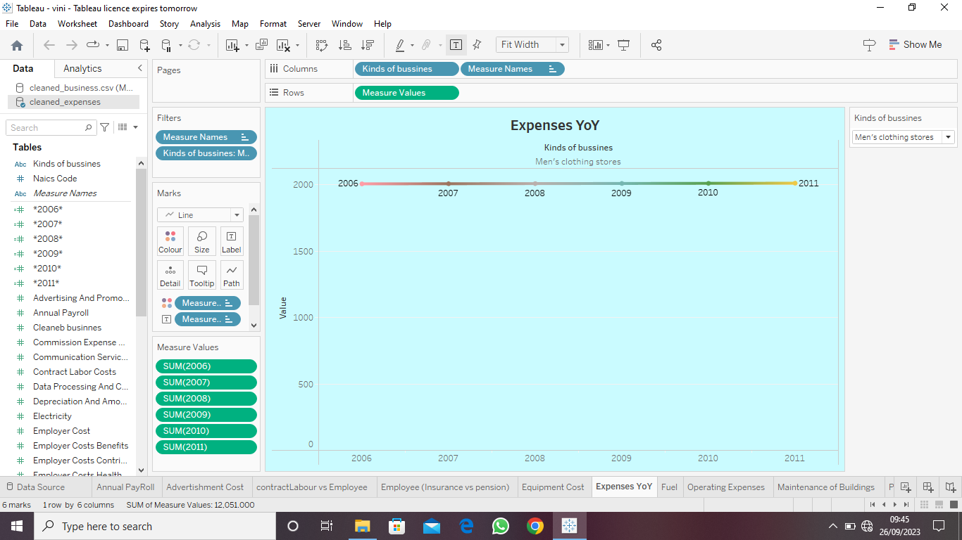

**ACTIVITY 1.7: FUEL**

[**https://drive.google.com/file/d/1Lma4_uFLjOFkobnFr5eFsoUTwdcOv-CW/view?usp=drive_link**](https://drive.google.com/file/d/1Lma4_uFLjOFkobnFr5eFsoUTwdcOv-CW/view?usp=drive_link)

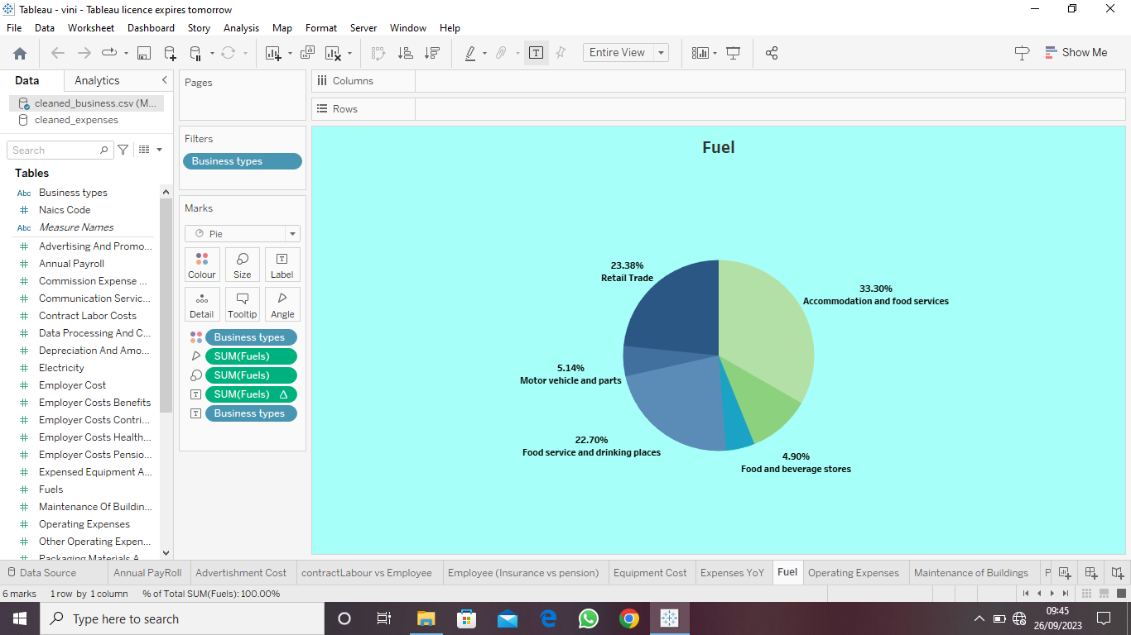

**ACTIVITY 1.8: MAINTENANCE OF BUILDINGS**

[**https://drive.google.com/file/d/1xbKBU6tYhDhVqFfBnzirYUf46Qm8ivK0/view?usp=drive_link**](https://drive.google.com/file/d/1xbKBU6tYhDhVqFfBnzirYUf46Qm8ivK0/view?usp=drive_link)

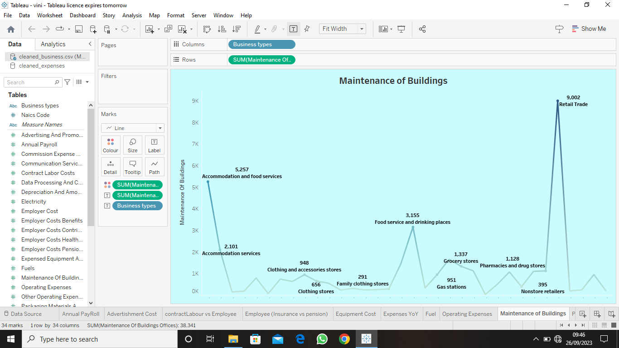

**ACTIVITY 1.9: POWER EXPENDITURE**

[**https://drive.google.com/file/d/1u0Q6xjyKqHtDZRQO3XfzcoZsOb7OUa9c/view?usp=drive_link**](https://drive.google.com/file/d/1u0Q6xjyKqHtDZRQO3XfzcoZsOb7OUa9c/view?usp=drive_link)

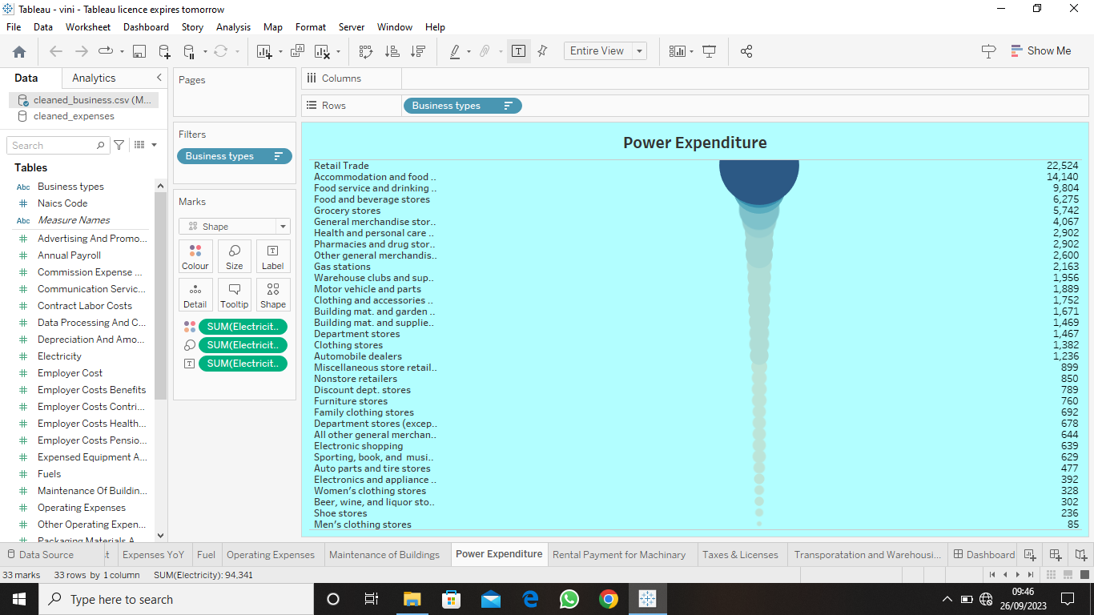

**ACTIVITY 1.10: RENTAL PAYMENT MACHINERY**

[**https://drive.google.com/file/d/1TGgrOreO9WwG7PxfH7PMIidF1d896jhg/view?usp=drive_link**](https://drive.google.com/file/d/1TGgrOreO9WwG7PxfH7PMIidF1d896jhg/view?usp=drive_link)

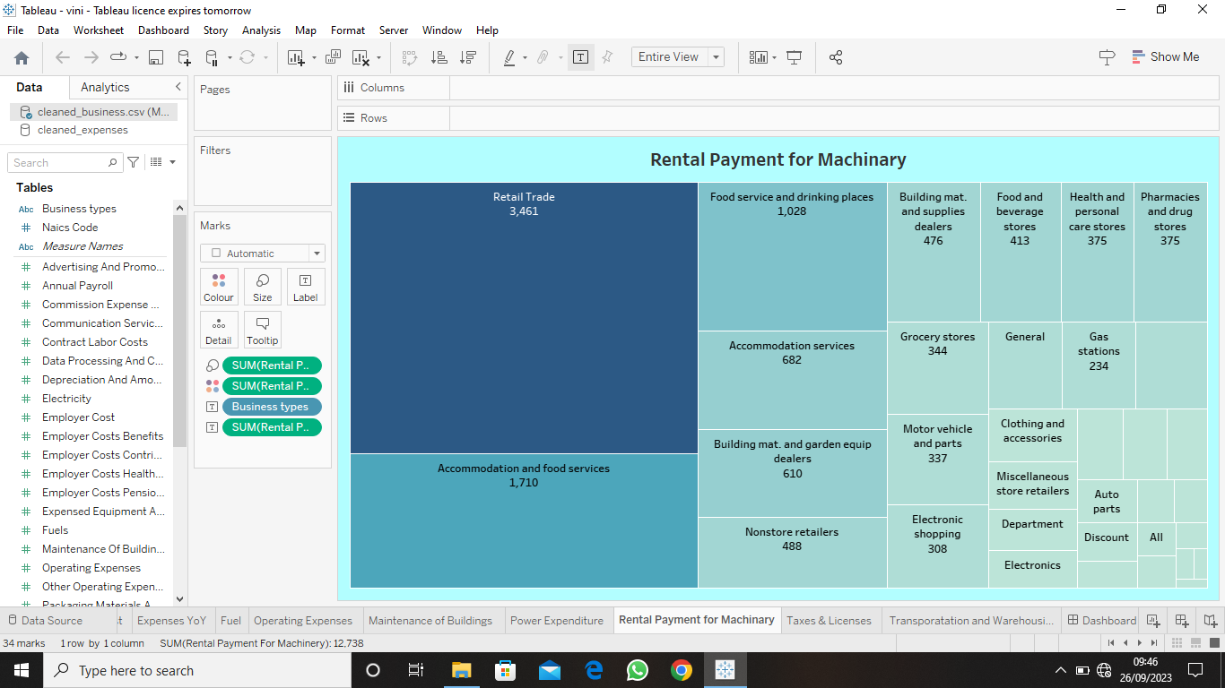

**ACTIVITY 1.11: TAXES & LICENSES**

[**https://drive.google.com/file/d/1-7-tlb1oeKa2P3ryPrB_9WC3Io57TKcO/view?usp=drive_link**](https://drive.google.com/file/d/1-7-tlb1oeKa2P3ryPrB_9WC3Io57TKcO/view?usp=drive_link)

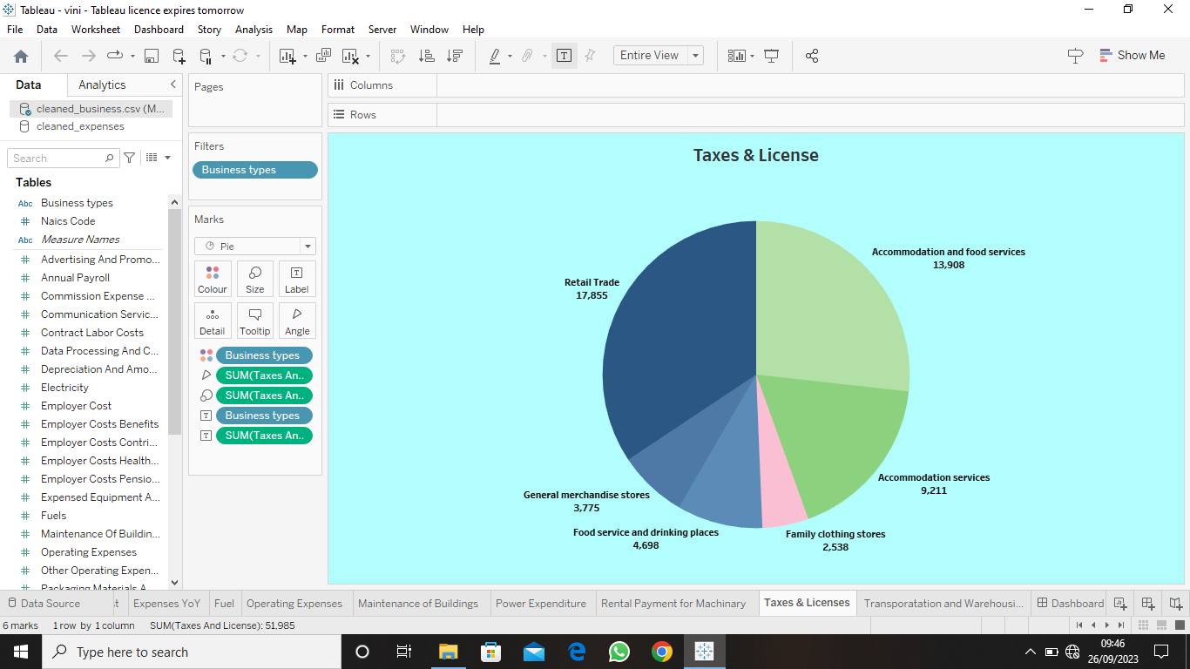

**ACTIVITY 1.12: TRANSPORTATION**

[**https://drive.google.com/file/d/1-b0IXQn9Rym_TnCoDOebdaEZcmpPdICr/view?usp=drive_link**](https://drive.google.com/file/d/1-b0IXQn9Rym_TnCoDOebdaEZcmpPdICr/view?usp=drive_link)

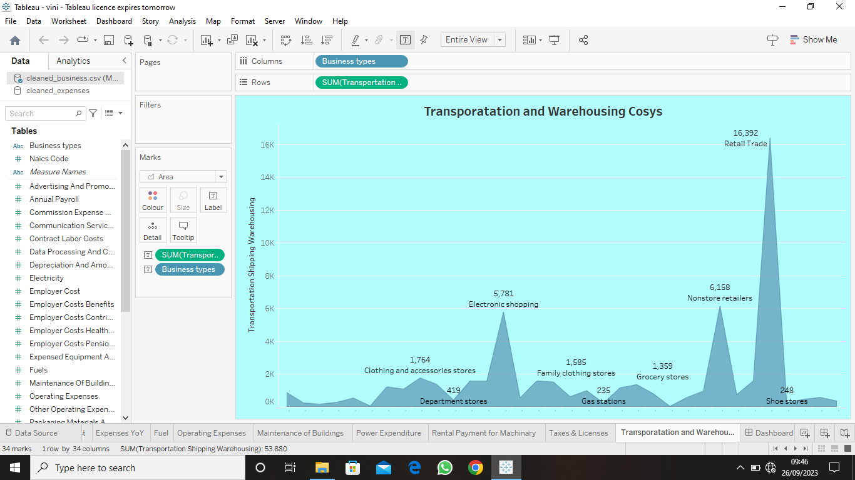

**MILESTONE 5: DASHBOARD**

**A dashboard is a graphical user interface (GUI) that displays information and data in an organized, easy-to-read format. Dashboards are often used to provide real-time monitoring and analysis of data and are typically designed for a specific purpose or use case. Dashboards can be used in a variety of settings, such as business, finance, manufacturing, healthcare, and many other industries. They can be used to track key performance indicators (KPIs), monitor performance metrics, and display data in the form of charts, graphs, and tables**.

**ACTIVITY 1: RESPONSIVE AND DESIGN OF DASHBOARD**

**Once you can created views on different sheets in Tableau, you can pull them into a dashboard.**

**ACTIVITY 1.1: DASHBOARD 1**

[**https://public.tableau.com/views/NM2023TMID08543/Dashboard1?:language=en-US&:display_count=n&:origin=viz_share_link**](https://public.tableau.com/views/NM2023TMID08543/Dashboard1?:language=en-US&:display_count=n&:origin=viz_share_link)

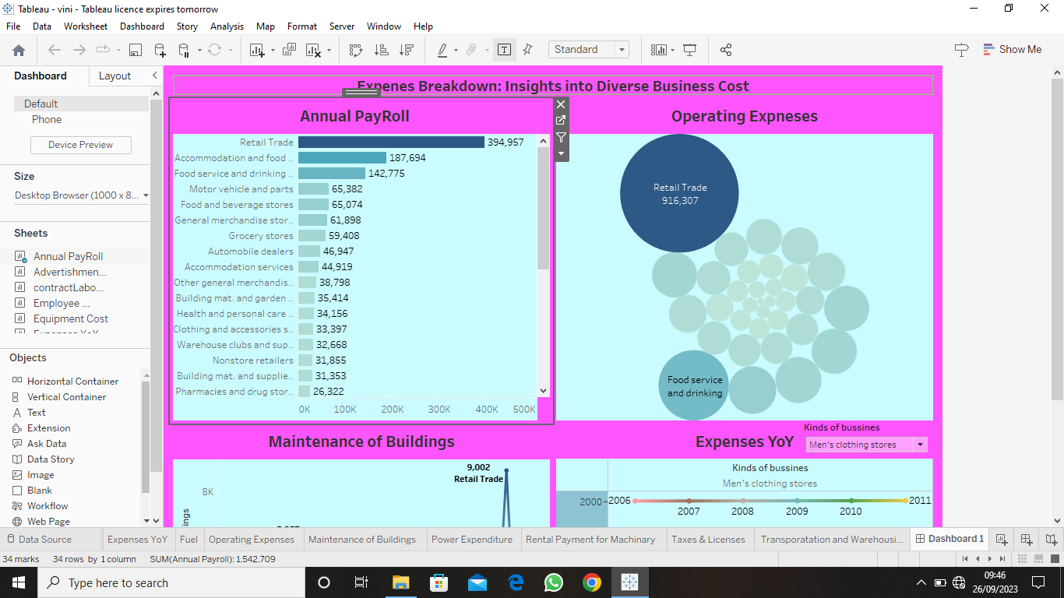

**ACTIVITY 1.2: DASHBOARD 2**

[**https://public.tableau.com/views/NM2023TMID08543Dashboard2/Dashboard2?:language=en-US&:display_count=n&:origin=viz_share_link**](https://public.tableau.com/views/NM2023TMID08543Dashboard2/Dashboard2?:language=en-US&:display_count=n&:origin=viz_share_link)

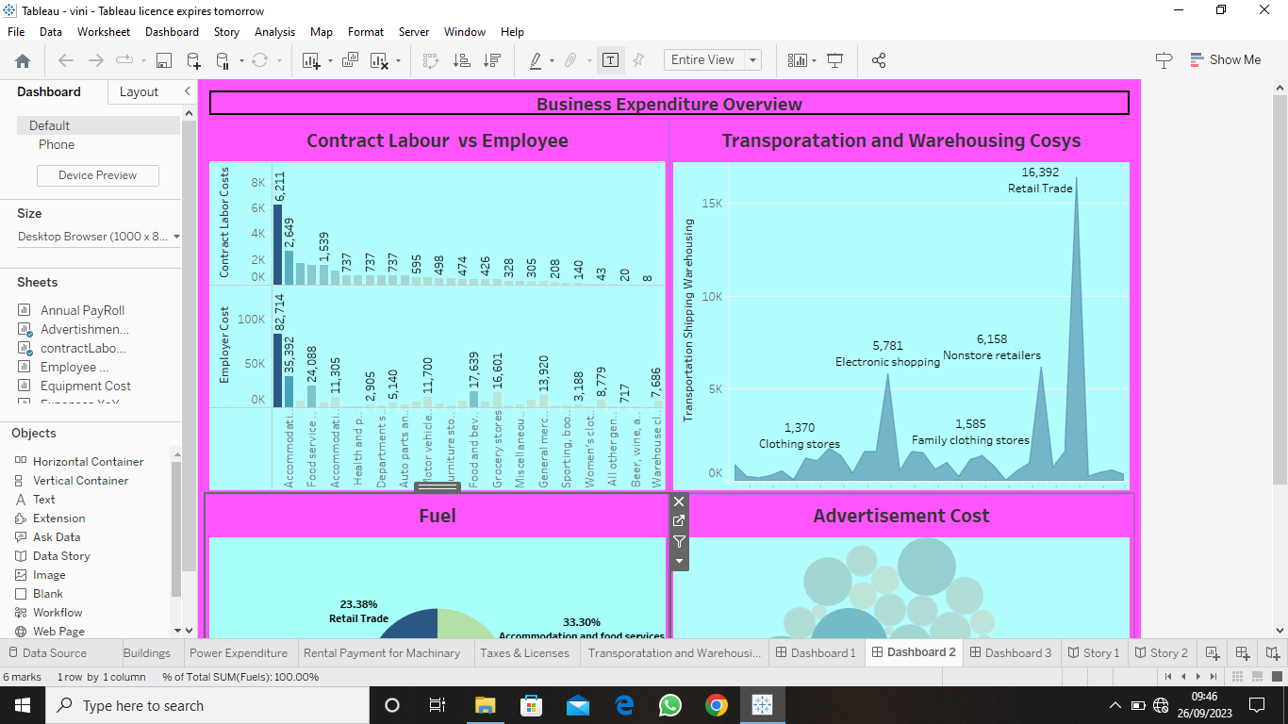

**ACTIVITY 1.3: DASHBOARD 3**

[**https://public.tableau.com/views/NM2023TMID08543Dashboard3/Dashboard3?:language=en-US&:display_count=n&:origin=viz_share_link**](https://public.tableau.com/views/NM2023TMID08543Dashboard3/Dashboard3?:language=en-US&:display_count=n&:origin=viz_share_link)

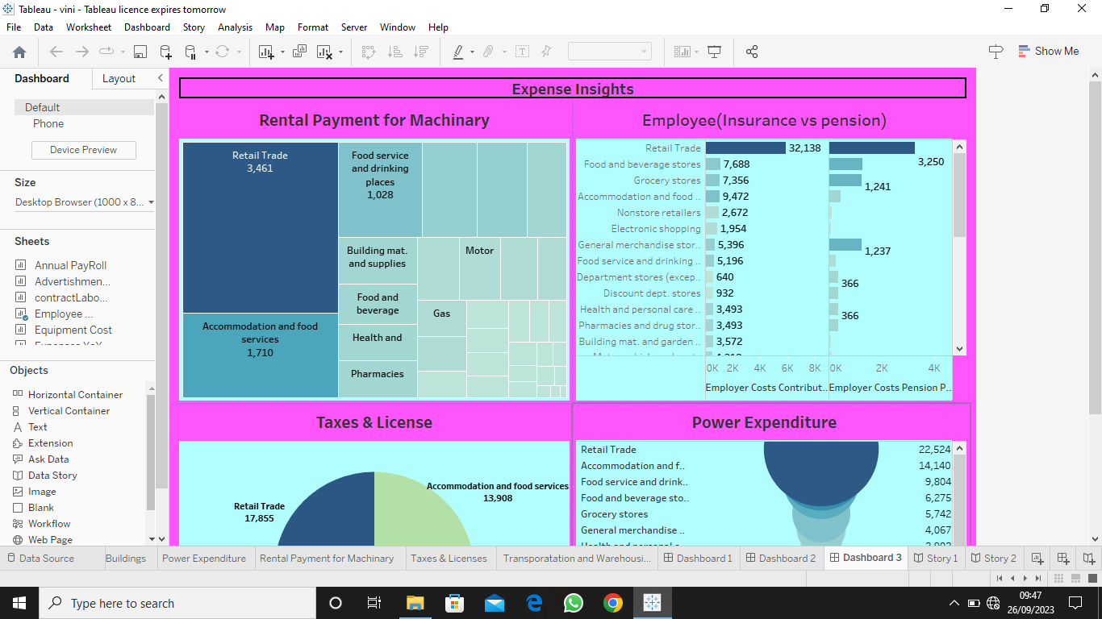

**MILESTONE 6: STORY**

**A data story is a way of presenting data and analysis in a narrative format, intending to make the information more engaging and easier to understand. A data story typically includes a clear introduction that sets the stage and explains the context for the data, a body that presents the data and analysis logically and systematically, and a conclusion that summarizes the key findings and highlights their implications. Data stories can be told using a variety of mediums, such as reports, presentations, interactive visualizations, and videos.**

**ACTIVITY 1: NO OF SCENES IN A STORY**

**The number of scenes in a storyboard for a data visualization analysis of the performance of banks will depend on the complexity of the analysis and the specific insights that are trying to be conveyed. A storyboard is a visual representation of the data analysis process and it breaks down the analysis into a series of steps or scenes.**

**ACTIVITY 1.1: STORY 1**

[**https://public.tableau.com/views/NM2023TMID08543Story1/Story1?:language=en-US&:display_count=n&:origin=viz_share_link**](https://public.tableau.com/views/NM2023TMID08543Story1/Story1?:language=en-US&:display_count=n&:origin=viz_share_link)

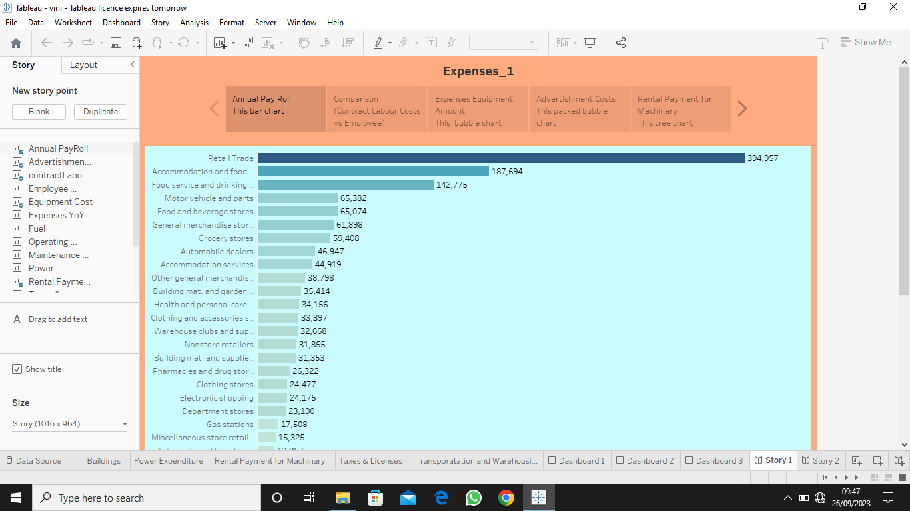

**ACTIVITY 1.2: STORY 2**

[**https://public.tableau.com/views/NM2023TMID08543Story2/Story2?:language=en-US&:display_count=n&:origin=viz_share_link**](https://public.tableau.com/views/NM2023TMID08543Story2/Story2?:language=en-US&:display_count=n&:origin=viz_share_link)

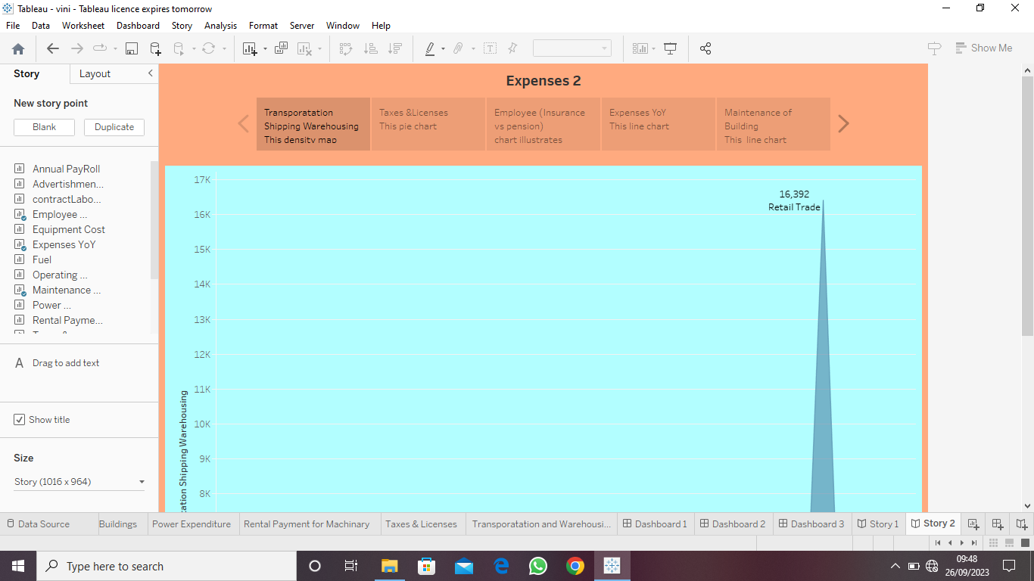

**MILESTONE 7: PUBLISHING**

**DASHBOARD 1:**

[**https://public.tableau.com/views/NM2023TMID08543/Dashboard1?:language=en-US&:display_count=n&:origin=viz_share_link**](https://public.tableau.com/views/NM2023TMID08543/Dashboard1?:language=en-US&:display_count=n&:origin=viz_share_link)

**DASHBOARD 2:**

[**https://public.tableau.com/views/NM2023TMID08543Dashboard2/Dashboard2?:language=en-US&:display_count=n&:origin=viz_share_link**](https://public.tableau.com/views/NM2023TMID08543Dashboard2/Dashboard2?:language=en-US&:display_count=n&:origin=viz_share_link)

**DASHBOARD 3:**

[**https://public.tableau.com/views/NM2023TMID08543Dashboard3/Dashboard3?:language=en-US&:display_count=n&:origin=viz_share_link**](https://public.tableau.com/views/NM2023TMID08543Dashboard3/Dashboard3?:language=en-US&:display_count=n&:origin=viz_share_link)

**STORY 1:**

[**https://public.tableau.com/views/NM2023TMID08543Story1/Story1?:language=en-US&:display_count=n&:origin=viz_share_link**](https://public.tableau.com/views/NM2023TMID08543Story1/Story1?:language=en-US&:display_count=n&:origin=viz_share_link)

**STORY 2:**

[**https://public.tableau.com/views/NM2023TMID08543Story2/Story2?:language=en-US&:display_count=n&:origin=viz_share_link**](https://public.tableau.com/views/NM2023TMID08543Story2/Story2?:language=en-US&:display_count=n&:origin=viz_share_link)

**CONCULSION**

1. **Build a list of project tasks and the resources you’ll need to deliver them. A work breakdown structure is an excellent tool for this.**
2. **Estimate how long you’ll need and create a project schedule.**

**REFRENCE:**

[**https://en.m.wikipedia.org/wiki/Talk:Expense_management**](https://en.m.wikipedia.org/wiki/Talk:Expense_management)